Case Study:

From Diodes to OLED Displays

By Quentin Delhaye (IT)  
& Gauthier Roig (EM)

# Summary

Abstract 2

Introduction 2

I. Diodes 3

1. Physical Principles 3

A. Silicon electrical conductivity 3

B. Doping semiconductors 4

2. P-N junctions 4

A. Potential barrier 4

B. Forward and reverse bias 5

3. Diodes 5

A. Diodes characteristics 5

B. Diodes applications 6

C. Diodes life-cycle=blabla! 6

II. Light Emitting Diodes 7

1. Physical principle 7

A. Photons emission 7

B. Colours 7

2. LEDs efficiency 9

A. Comparison between Incandescent, CFL and LED lamps 9

B. Curiosity: Efficiency above the unity of a LED 10

3. LED applications 11

4. Impact of LEDs on the environment=blabla! 11

III. Organic Light Emitting Diodes 12

Conclusion 13

Annotated Bibliography 14

Appendix 17

Study Outline 17

# Abstract

250 Words – “(please follow the instructions and template found on the Virtual University)”

# Introduction

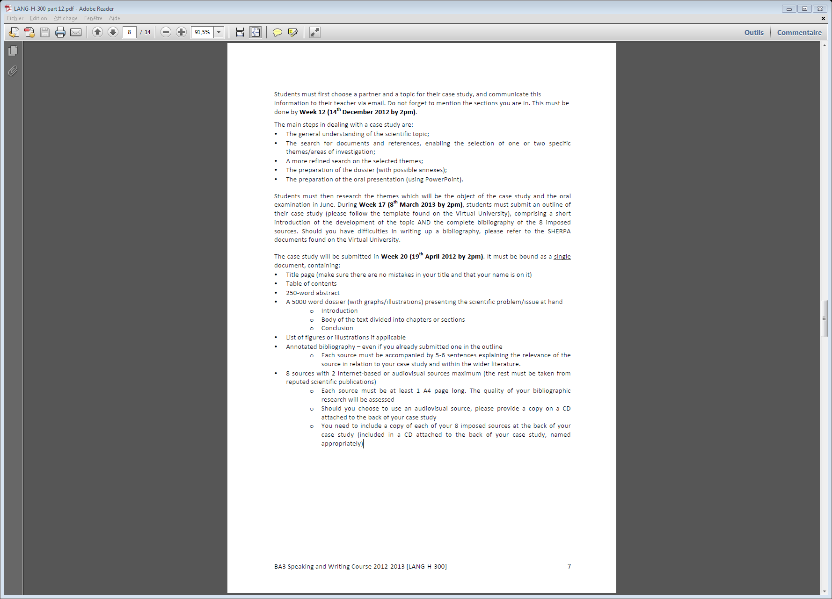

# Diodes

Introduction to the chapter and summary of it (+reference to Mohan/ELEC-H-301 for the structure)

## Physical Principles

### Silicon electrical conductivity

The electrical conductivity of a material is its capability to conduct an electric current <Wikipedia[1]>.

In semiconductors, and particularly in silicon components, the conductivity is due to the ability of two different electric charges to move inside the material: positive and negative.

Indeed, in silicon[2] monocrystals, four valence electrons are bonded covalently <figure-book-Joelle-p11>, which implies that silicon nucleuses tend to attract electrons as much as they abandon them. Therefore, if an electron escapes the scope of a nucleus in a certain direction, the charge of the considered atom is locally disturbed positively. An electron coming from the opposite direction is then caught to compensate this lack of charge, and the problem is transferred to the neighbouring atoms, then further and further in the material.

Thereby, if negative charges (electrons) can simply move inside the material, positive charges can also be shifted by transfers of lacks of electrons (which are called “holes” here under).

However, this principle cannot be perceived easily at the macroscopic level for a simple piece of material isolated from its external environment. The reason is that, as all the movements appear in such directions that none of them distinguishes from the others, the global contribution of all the movements inside the material is statistically zero/nul.

To get it visible, one could/can for instance establish an electric field between the two extremities of the considered material, so that a preferential movement’s direction would exist within it. Electrons would indeed tend to move in the aim of compensating the imposed positive charge on one extremity; what would let holes move to the other extremity. <figure(Robert?)>

Depending on their electrical conductivities, materials are classified generally in two categories: conductors, which well conduct the electricity, and insulators, which do not. Semiconductors are positioned between the two: they conduct the electricity, but not enoughto be considered as conductors. <numbers:Mohan-p.508>

### Doping semiconductors

The reason why semiconductors are used whereas they neither well conduct the electricity nor well prevent it, is that the conductivity can be changed by introducing impurities into the material.

Indeed, it is possible to insert some other atoms which have only 3 or 5 valence electrons into the material to affect its properties.

Atoms of *Group IIIa* elements in the periodic table (3 valence electrons), such as Boron, Aluminium or Gallium, need to catch 5 electrons to get the same electronic configuration as a noble gas (*octet rule*) instead of only 4 like Silicon. What results from this is that, by catching an extra electron, one hole is set free, what makes the material positively doped (“*p-doped*”).

Similarly, atoms like Phosphor, Arsenic or Antimony, from *Group Va* of the periodic table (5 valence electrons), need to seize 3 electrons instead of 4, what leaves the material negatively doped (“*n-doped*”) with an extra free electron.

The electrons and holes densities (respectively $n$ and $p$) are quite poor in natural Silicon ( $n=p \sim {10}^{10}cm^{-3}$ at room temperature[3]) compared with the densities obtained by doping, which become the densities of the added atoms inside the material ( $p$ or $n={10}^{19} cm^{-3}$ or less) as far as the natural Silicon densities are negligible, because every single additional atom causes an extra hole or free electron. It is then possible, by controlling the local densities of the material, to affect the conductivity of a piece of Silicon, which is directly linked to those densities.

Several processes are used today for doping semiconductors, which consist globally in an epitaxy[4] of a doping material on a semiconductor one.

## P-N junctions

A $p$- $n$ junction is the placing side by side of two different doped semiconductor (or regions of a same semiconductor): a $p$-doped and an $n$-doped one. <figure>

### Potential barrier

When an n-doped semiconductor is apposed to a p-doped one, some of the extra electrons in the vicinity of the junction (on the n-doped side) will be attracted to the holes of the other side (p-doped) of the junction and will then pass through it. By diffusing on the other side, electrons leave impurities charged positively. This causes the existence of a layer, near to the junction, where electroneutrality is no more ensured as those positive ions cannot move on the one hand, nor seize other electrons on the other hand, because there is no more electrons to catch in their vicinity.

By analogy, some of the extra holes on the p-doped side of the junction will cross it and let behind them appear a layer charged negatively.

The presence of charged layers on both sides of the junction (which union is called “*space charge layer*” or “*depletion region*”) causes then the existence of an electric field between them two. This field is called a “*barrier potential*” and prevents electrons and holes from crossing naturally the depletion region.

This principle is illustrated by the figure below, extracted from Mohan’s book on page 514.

### Forward and reverse bias

If a $p$- $n$ junction is forward biased, that is if one imposes an external voltage ($V$) across it in such a way that the positive and negative potentials are respectively connected to the $p$- and $n$-doped sides of the junction, holes will be repulsed in the p-doped side and the same will happen in the n-doped one for electrons. This repulsion will then tend to shrink the height of the potential barrier. Hence, after a certain value of the imposed voltage (“*threshold value*” $V_{TH}$) corresponding to a null value of the potential barrier, the $p$- $n$ junction starts conducting the current normally. <figure>

On the contrary, if the imposed voltage is reversed relatively to the previous case, the $p$- $n$ junction is reverse biased and the potential barrier grows as the imposed voltage grows. <we-could-get-that-part-of-the-work-longer-if-there-is-not-enough-words-at-the-end>

## Diodes

Diodes are $p$- $n$ junctions with two electrical terminals on its extremities.

### Diodes characteristics

Considering the reasoning mentioned above about forward and reverse currents, it can be understood that the idealised characteristics ($I$- $V$ diagram) of a diode looks as follows: beneath a threshold value of the voltage ($V$ < $V_{TH}$), the diode does not conduct the current; after what it does ($I$ > $0$).

<idealised-diode-characteristic>

However, three differences between the ideal characteristic of a diode and its real one (shown hereunder) exist, which will only be mentioned among others because the only parts of the curve that are interesting in this case are situated on positive values of current and voltage.

<real-diode-characteristic>

At first, the part of the curve that corresponds to a conductive diode ($I$ > $0$) is not purely vertical but exponential. According to this, the bigger the imposed voltage over the diode, the bigger the current passing through it.

At second, contrarily to what can imply what is mentioned before concerning reverse biasing, a small reverse current (called “*leakage current*”) appears for negative voltage.

At third, over a certain (absolute) value of negative voltage (called “*breakdown voltage*”), the current becomes very high, the power consumed by the diode ($P=I.V$) too, and the diode can be damaged or destroyed.

### Diodes applications

Diodes are electronic components that are nowadays used in a very wide range of applications. In this section are mentioned only three uses made of diodes but this list is definitely not exhaustive. The only one goal here is to illustrate the fact that diodes are very used today.

A first use of diodes is its use as light emitting components. Indeed, as it will be dealt with in the two other parts of this work, certain diodes are able to emit light in certain conditions.

Another use of diodes is as power devices: it can for instance be used in rectifiers, to convert an alternating current into a direct one, or in other components protection by limiting the tension across it.

Diodes are also used in logic, to construct AND or OR logic gates.

### Diodes life-cycle=blabla!

# Light Emitting Diodes

A Light Emitting Diode (*LED*) is a particular case of diodes that, as its name indicates it, is able to emit light.

Generally, LEDs have higher threshold voltages than simple diodes, as indicated in the following graph.What-is-the-reason-of-this??<joelle’s-book-p.37>

## Physical principle

### Photons emission

As mentioned in the previous section, recombination of electrons and holes happen when a diode is forward biased.

For filling a hole, an electron first needs to be able to move inside the material. For doing it, it then also needs to have a sufficiently high energy to be able to get detached of the atoms it is linked to at the initial moment.

However, if one focuses on the ending state of the recombination, that is when the recombination of the free electron with a hole is achieved, one can understand that, if the electron is anew attached to a fixed atom, it means that its energy has been reduced during the recombination event.

Therefore, by applying the law of conservation of energy, one can apprehend that the energy lost by the electron has been transformed into other forms of energy.

In general, for diodes, this transformation occurs into heat; but in the particular case of LEDs, the reduction of energy of the electron is obtained by emitting a photon.

<oui-oui:171words-to-say-that-LEDs-emit-photons☺Faut-bien-arriver-à-5000…>

To favour a well perceivable emission of photons, LEDs are constructed differently from simple diodes. For example, in LEDs, $p$- and $n$-junctions are not simply sticked together but are arranged in such a way that a maximum of photons leaves at first the material in a certain direction, before getting diffused by a lens, as indicated in this figure.<Joelle’s-book-p.36>

### Colours

The colour of the emitted light of a LED is one of its characteristics and depends directly on its construction materials.

Indeed, the composition of the $p$- $n$ junction governs the energy levels of the moving and caught electrons. Those two levels, respectively called “*conduction band*” and “*valence band*” energy levels, determine their difference, the “*band gap*” energy, which is the energy of the photon emitted ($E$) when an electron finishes a recombination.

The colour of light thereby emitted is imposed by its wavelength ($λ$), itself imposed by the band gap in respect with Planck’s relation:

$$E=\frac{hc}{λ}$$

where $h≅{6.63 10}^{-34} Js$ is Planck’s constant

and $c≅300,000 m/s$ is the speed of light.

The following figure, coming from NASA’s website[5] shows the types of emitted photons according to their wavelengths. For what concerns LEDs, only the part from $10 nm$ to $1 mm$ of this illustration is relevant; nay even the part from $400 nm$ to $700 nm$ if ultraviolet and infrared rays are not considered.

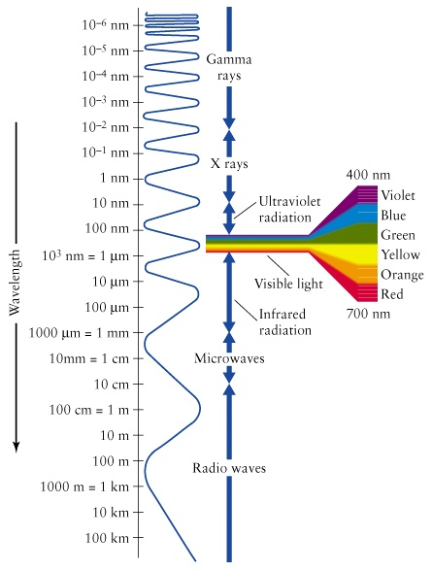

The table here above, which data come from an article of a LED manufacturer[6], regroups LEDs compositions used to produce the different colours.

|  |  |  |
| --- | --- | --- |
| LEDs Colours | Wavelengths | LEDs Compositions |
| Ultraviolet | $$320 nm ⟶ 360 nm$$ | $$GaN / AlGaN$$ |
| Violet $⟶$ Green | $$395 nm ⟶ 530 nm$$ | $$InGaN$$ |
| Yellow-Green $⟶$ Red | $$565 nm ⟶ 645 nm$$ | $$AlInGaP$$ |
| Red $⟶$ Infrared | $$600 nm ⟶ 900 nm$$ | $$AlGaAs / GaAs$$ |

## LEDs efficiency

### Comparison between Incandescent, CFL and LED lamps

To deal with LEDs efficiency, it is quite frequent to consider the more particular case of LED lamps and compare it to other current lighting devices. This is why it will be discussed in this section about the efficiency of current LEDs and expected ones in less than five years, versus the two most other used lamps in our daily life: incandescent bulbs and compact fluorescent lamps (CFL).

As a basis of comparison, the table below was extracted from an analysis of the energy and environmental impacts of LED lightings[7].

|  |  |  |  |  |
| --- | --- | --- | --- | --- |
| Characteristics | Incandescent | CFL | LED lamp 2012 | LED lamp 2017 |
| Lumen Output [$lm$] | 900 | 825 | 812 | 824 |
| Power Consumption [$W$] | 60 | 15 | 12.5 | 6.1 |
| Efficiency [$lm/W$] | 15 | 55 | 65 | 134 |

By definition, the efficiency of an electric device is the ratio of what it procures to what it consumes.

Applied to lamps, this definition becomes naturally the ratio of the generated luminescence (in lumens – $lm$) to the consumed power $P = I.V$ (in watts – $W$).

Thereby, the table indicates that, if LEDs are a bit less luminescent than other contemporary lamps (respectively - $9.8\%$ and - $1.6\%$ in comparison to incandescent and fluorescent lamps), they are characterised by a significant lower power consumption (- $79.2\%$ and - $16.7\%$) that makes them more efficient ( $333\%$ and $18.2\%$ extra efficiency).

Also, it is projected that, in five years’ time, LEDs’ power consumption will be reduced to half of their current value, which would double their present-day efficiency.

In conclusion, LED lamps, with their $65 lm/W$ efficiency value, are the best lighting devices in terms of efficiency, which explains why they are so used nowadays.

### Curiosity: Efficiency above the unity of a LED

Coming back to LEDs as small components, here above is noticed a curiosity: three scientists of the *Massachusetts Institute of Technology* in Cambridge (Parthiban Santhanam, Joseph Gray, Jr. Dodd and J. Ram Rajeev) found that, in certain conditions, a LED could have efficiency greater than the unity.

It is to be noted, before starting analysing their article, that the efficiency’s definition used here (adimensionally) is different from the one that is used for lamps (in lumen/watt) and relates to the emitted photons’ and applied (by forward biasing the LED) energies:

$$η=\frac{Optical Power_{\left[W\right]}}{Consumed Power_{\left[W\right]}}$$

Also, it could let suppose wrongly, earlier in this work, that LEDs transform all their electrons’ extra energy by emitting light, but this would imply that here mentioned efficiency would always be equal to $1$ and is not the case in reality.

What is reported in their article[8] is that, by forward biasing very little an $InGaAsSb$ infrared LED with a $70 μV$ voltage at the temperature of $135°C$, the $0.1\%$ part of the electrons that is able to pass through the LED[9] was emitting photons of $69$ ($±11$) $pW$ of optical power, while electrical power of only $29.9$ ($±0.1$) $pW$ was used at the input of the LED. This result, which means that the LED’s efficiency was between $193.3\%$ and $277.8\%$, is explained being possible by a cooling down of the environment of the recombined holes.

Such a result can be quite surprising in so far as the second law of Thermodynamics prohibits the creation of work from the ambient environment without interaction with a second heat source. Facing to this remark, it should be pointed out that photons have entropy and, therefore, entropy grows when photons are emitted; implying that light should not be seen as work but well as heat.

Concerning the applications that this principle could find in the future, people would logically think about free refrigerators that would need to produce light to work, but Santhanam remains more modest[10]: “*My personal opinion is that it's more likely to be useful as a light source. Refrigerators are mostly useful when they are high power. Light sources, however, are used in all kinds of ways. In particular, light sources used for spectroscopy and communication don't necessarily need to be very bright. They just need to be bright enough to be clearly distinguishable from some background noise*.”

## LED applications

Due to their electroluminescence, LEDs are diodes that have various applications as lighting devices. Three of them are cited in this section.

First, LEDs can be used as big components. Indeed, in lamps or car headlights, only a few LEDs are present as it can be seen hereafter.

<images-of-LED-lightings>

[*http://www.dimensionsinfo.com/wp-content/uploads/2010/01/LED-Lamp.jpg*](http://www.dimensionsinfo.com/wp-content/uploads/2010/01/LED-Lamp.jpg)

[*http://www.plasmaglow.com/images/products_accessories_lightn.jpg*](http://www.plasmaglow.com/images/products_accessories_lightn.jpg)

Second, in contrast to the previous case, LEDs can also be used as tiny components, such as in LED displays, where thousands and thousands of LEDs as small as possible are combined together to get the best visual rendering. In the case of the new technology of televisions (4k Ultra HD), it is even higher, with millions of pixels for $3840$ x $2160$ resolutions displays.

<image-of-a-(4k)-(O)-LED-tv>

Third, small LEDs can be manipulated to serve in galvanic isolations to protect circuits or loads in electrical systems. Indeed, associated with a photodiode that, counter to LEDS, let currents flow through it when it is exposed to light, a LED forms an optocoupler that permit to transfer an electrical signal between two circuits without physical contact.

<image-of-an-optocoupler>http://en.wikipedia.org/wiki/Optocoupler

## Impact of LEDs on the environment=blabla!

# Organic Light Emitting Diodes

early LED displays, evolution from LED to OLED, comparison with LCD technology

* **LED Displays**

LED (7 segments)

OLED (potentially AMOLED)

Comparison between OLED & LCD

Future Prospects

# Conclusion

# Annotated Bibliography

Annotated in 150 Words (4-5 sentences explaining the main ideas you used or why you chose this source)

BRÜTTING, Wolfgang, Stefan BERLEB, Anton G. MÜCKL. 2001. “Device Physics of Organic Light-Emitting Diodes Based on Molecular Materials” in *Organic Electronics*. N°2. Editions Elvesier. Bayreuth: University of Bayreuth.

FLEEMAN, Stephen R. 1990. *Electronic Devices: Discrete and Integrated.* Prentice Hall International. New Jersey. pp. 9-12; pp. 18-42.

The reason we chose this source while we already had a reference for what concerns semiconductors and $p$- $n$ junctions ([MOHAN]) is that, as it gave us a vision more “chemical” of these concepts, it focused on several points where Mohan’s book was sometimes not enough explicit, such as holes’ recombination.

Furthermore, we did not choose it only as a complementary source: it also informed us about how LEDs work and how diodes in general are made.

INSTITUTE FOR LARGE AREA MICROELECTRONICS, Univesität Stuttgart. Update: 25-07-2011. *Organic Light-Emitting Diodes (OLEDs)*. Website on the INTERNET. <http://www.igm.uni-stuttgart.de/forschung/arbeitsgebiete/oled/index.en.html>*.* Last consultation: 16-03-2013.

MOHAN, Ned, Tore M. UNDELAND, William P. ROBBINS. 1995. *Power Electronics: Converters, Application and Design*. John Wiley & Sons, Inc. – 2nd Edition. New York. pp. 507-520.

This book is the reference book of one of our course (*ELEC-H-312: Conversions Electroniques de l’Energie – Professor: Johan Gyselinck*), where it is very frequently mentioned as a real reference for all electronic power supplies, such as diodes.

Due to its clarity and completeness, it was used for its introduction to diodes (Chapter 19: Basic Semiconductors) instead of its chapter on diodes itself (Chapter 20: Power Diodes) because this one was too focused on power diodes, which were quite far from light-emitting diodes. The main concepts on which this work is based on are then semiconductors’ conductivity and $p$- $n$ junctions, including their characteristics.

Those pieces of information were confronted to the equivalent ones coming from [FLEEMAN].

PEDDINTI, Vijay Kumar. 2008. *ELE 432 – Electrical Engineering Materials Course of University of Rhodes Island: Light Emitting Diodes (LEDs).*University of Rhodes Island.

There are two reasons explaining why we chose this reference:

* On the one hand, it offered a list of the different advantages and disadvantages of LEDs, what we were looking for before starting writing; and as we needed to be able to attribute some credit to this source (because if finding such a list on the Internet is really an easy thing, the reliability of sources found that way is sometimes disputable), the fact it is part of a University course satisfied us.
* On the other hand, it seemed to explain precisely the principle of LEDs’ photons emission and how to characterise LEDs in terms of efficiency.

However, it is to be noticed that, while writing the present case study, we realised that the text on those two concepts (photons emission and efficiency) were too implicit to be clearly understood. Fortunately, Fleeman’s book and Santhanam’s article gave us what we needed to do it the right way.

ROBERT, Frédéric. 2012. *ELEC-H-301 – Electronique Appliquée: Fonctionnement interne des composants électroniques*. Université Libre de Bruxelles.

The present work is based on this source even if it is a French one, for the following reasons.

At first, this is a course that we had on the first semester of the year; which implies that, even if we were not questioned about this chapter at the exam (what makes us do not know it as well as others), we had some basis notions about $p$- $n$ junctions before starting this work and we wanted to indicated it in our bibliography.

What follows, all the data that could come from this course were always found in those two: [FLEEMAN] & [MOHAN].

Finally, we only used this reference as a thread for our first chapter and not as other sources.

RUSS, Dahl, Opto Diode Corporation. 2008. *Light Emitting Diode Primer*. Website on the INTERNET. [http://optodiode.com/pdf-library/Russ%20D.%20RP%20Light%20Emitting%20  
Diode%20Primer%201.08.09%20%20FINAL.pdf](http://optodiode.com/pdf-library/Russ%20D.%20RP%20Light%20Emitting%20Diode%20Primer%201.08.09%20%20FINAL.pdf)*.* Last consultation: 16-03-2013.

This document, which is quite short (2 pages only), appeared to provide us, when we were writing our study outline, a way to link LEDs’ compositions to their wavelengths from the point of view of a LEDs’ manufacturer[11]. Nonetheless, as we understood later that amounts of materials and, by corollary, doping possibilities, existed, and that it was therefore quite difficult to make a correlation between used components and emitted light colour, we preferred mentioning the content of this document as examples only.

SANTHANAM, Parthiban, Dodd Joseph Jr. GRAY, Rajeev J. RAM. 2012. *Thermoelectrically Pumped Light-Emitting Diodes Operating above Unity Efficiency.* American Physical Society. Cambridge.

Cf. [WOGAN].

SCHOLAND, Michael J., N14 Energy Limited, Heather E. DILLON, Pacific Northwest National Laboratory. 2012. *Life-Cycle Assessment of Energy and Environmental Impacts of LED Lighting Products: LED Manufacturing and Performance*. Website on the INTERNET. <http://apps1.eere.energy.gov/buildings/publications/pdfs/ssl/2012_led_lca-pt2.pdf>. Last consultation: 10-04-2013. pp. 23-47.

The reliability of this report is warranted by the fact it is an account of work intended for the U.S. Government (Department of Energy).

We have extracted data from this document to establish our comparison between LED, CFL and Incandescent bulbs, in order to deal with LEDs’ efficiency.

SCHOLS, Sarah. 2011. *Device Architecture and Materials for Organic Light-Emitting Devices: Targeting High Current Densities and Control of the Triplet Concentration*. Editions Springer Science+Business Media. Netherlands.

WOGAN, Tim, Physics World. Update: 08-03-2012. *Led Converts Heat Into Light*. Website on the INTERNET. <http://physicsworld.com/cws/article/news/2012/mar/08/led-converts-heat-into-light>*.* Last consultation: 16-03-2013.

This Physics World’s article is a vulgarization of Santhanam’s scientific article concerning the curiosity of a LED which efficiency can exceed the unity.

Actually, this curiosity is at the origin of the choice of our case study’s topic because, when we found it a few months ago, we were sufficiently interpellated to decide that we would like to mention it in our case study.

Nevertheless, we would like to point out that, even if this scientific communication is directly at the origin of the choice of our subject, we wanted through this work to present it as a curiosity only and not as the main part of it, inasmuch as we are not able to master all the concepts it deals with (which is although why we also used a vulgarization to understand it).

# Appendix

## Study Outline

Over the last few years, modern displays are being revolutionized. The current technology, LCD, is progressively being replaced by Organic Light Emitting Diodes (OLED) which does not only compete in the same field but also open new horizon. What is the revolution compared to the previous technology, what does it offer and how does it work? To understand OLED, a strong technical background is needed which will be structured as follows:

* Diodes: general description and characteristics, and historical background.
* Light Emitting Diodes (LED): difference with a regular diode, different compositions and colours. Some significant applications frequently used and technological curiosities, and how they are made.
* OLED Displays: early LED displays, evolution from LED to OLED, comparison with LCD technology.

OLED and its derivatives are the future, but how will they be used? All kinds of constructors are being offered a new world of opportunities; smartphones, televisions, advertising, windows and vehicles are as many products OLED displays may be embedded in. Some aspects of the technology still need development and improvement such as colour efficiency, or the lifetime of the materials. The manufacturing of these displays does not restrict to a plane surface, it is now possible to bend it in order to make it follow the curve of a structure, for example. However, large scale displays are still being researched to reduce the cost, thus allowing a commercialisation of more affordable devices. Nonetheless, OLED are already largely implemented in small devices and their presence will grow as quickly as they are thin and bendable.

1. http://en.wikipedia.org/wiki/Electrical_resistivity_and_conductivity
2. Si: *Group IVa* in the periodic table.
3. All the values of this section are coming from MOHAN… p 509-510.
4. http://en.wikipedia.org/wiki/Epitaxy
5. http://science-edu.larc.nasa.gov/EDDOCS/Wavelengths_for_Colors.html
6. RUSS, Dahl, Opto Diode Corporation
7. Life-Cycle Assessment of Energy and Environmental Impacts of LED Lighting Products – Part II p. 24
8. *Thermoelectrically Pumped Light-Emitting Diodes Operating above Unity Efficiency*
9. Due to that poor value, it was considered in the previous sections that no current could pass under the threshold voltage.
10. Those words are quoted by Tim Wogan, a *Physics World* science writer, in its article “*LED converts heat into light*”.
11. The position *of Opto Diode Corporation* as a LEDs’ manufacturer ensured its reliability.