**Report about multi-threaded execution**

**Group members:** Yuan Liu, Yudong Zhang, Xinye Cheng

1. **Build threads:**

In the project we use **std::thread** to create a new thread (this function is included in the thread library).

1. **Build synchronization:**

The C compiler will regard main function as a thread which will run with other threads simultaneously, thus if we don’t build synchronization, the program may get wrong result in some cases. Here is an example:



The picture in the right is try to apply threshold to the picture. But as you can see only, the half part get the right result, because the write file instruction execute before the below part finish apply threshold.

In our project we try to use two methods to build synchronization:

* 1. Mutex: This structure will protect the data will more than one threads try to read or write in it.
  2. Thread.join(): This function is try to block the program until the certain thread is done.

1. **Result and analysis:**

Here are the result of our programs:

For 2 threads

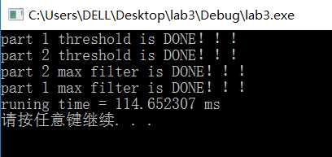

For 4 threads

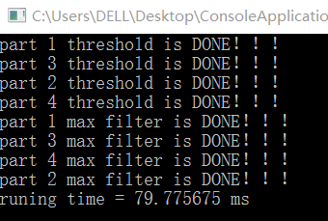

For 8 threads

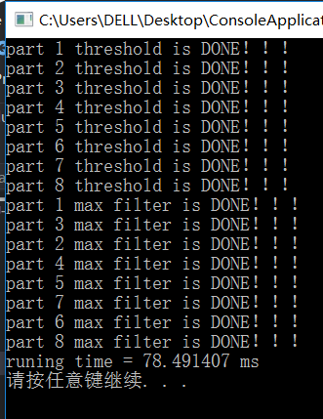

This result is very reasonable, with the increasing number of threads, we get better performance